Name: Astha Arpit Bhatt

Enroll: 196140316006

**Practical 17**

**Develop a simple JSP program for user login form with static and dynamic database**

Static :

**File name: index.html**

<html>

<head>

<title>Static Database</title>

</head>

<body>

<form action="Process.jsp" method="post">

Username:<input type="text" name="uname">

password:<input type="password" name="pass">

<input type="submit">

</form>

</body>

</html>

**File name: Process.jsp**

<%@page contentType="text/html" pageEncoding="UTF-8"%>

<!DOCTYPE html>

<html>

<head>

<title>JSP Page</title>

</head>

<body>

<%

String a=request.getParameter("uname");

String b=request.getParameter("pass");

if(a.equals("Astha") && b.equals("1210"))

{

response.sendRedirect("Welcome.jsp");

}

%>

</body>

</html>

**File name: Welcome.jsp**

<%@page contentType="text/html" pageEncoding="UTF-8"%>

<!DOCTYPE html>

<html>

<head>

<title>JSP Page</title>

</head>

<body>

<%

out.println("Welcome to world of jsp");

%>

</body>

</html>

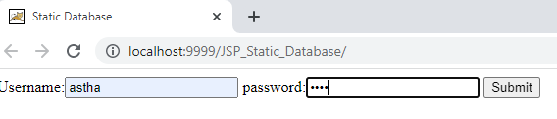

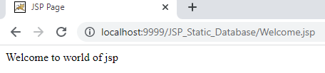

Dynamic: